EXPERIMENT NO 2

REDESIGN OF CANTEEN MENU

AIM: TO REDESIGN THE CANTEEN MENU IN DIFFERENT STYLE

PROCEDURE:CREATE A WIREFRAME ACCORDING TO YOUR DESIGN.

:SELECT THE FRAMEWORK FOR YOUR DESIGN.

:CREATE DESIGN AND ADD ICONS,IMAGES NEEDED FIR YOUR DESIGN.

:PROTOTYPE YOUR DESIGN.

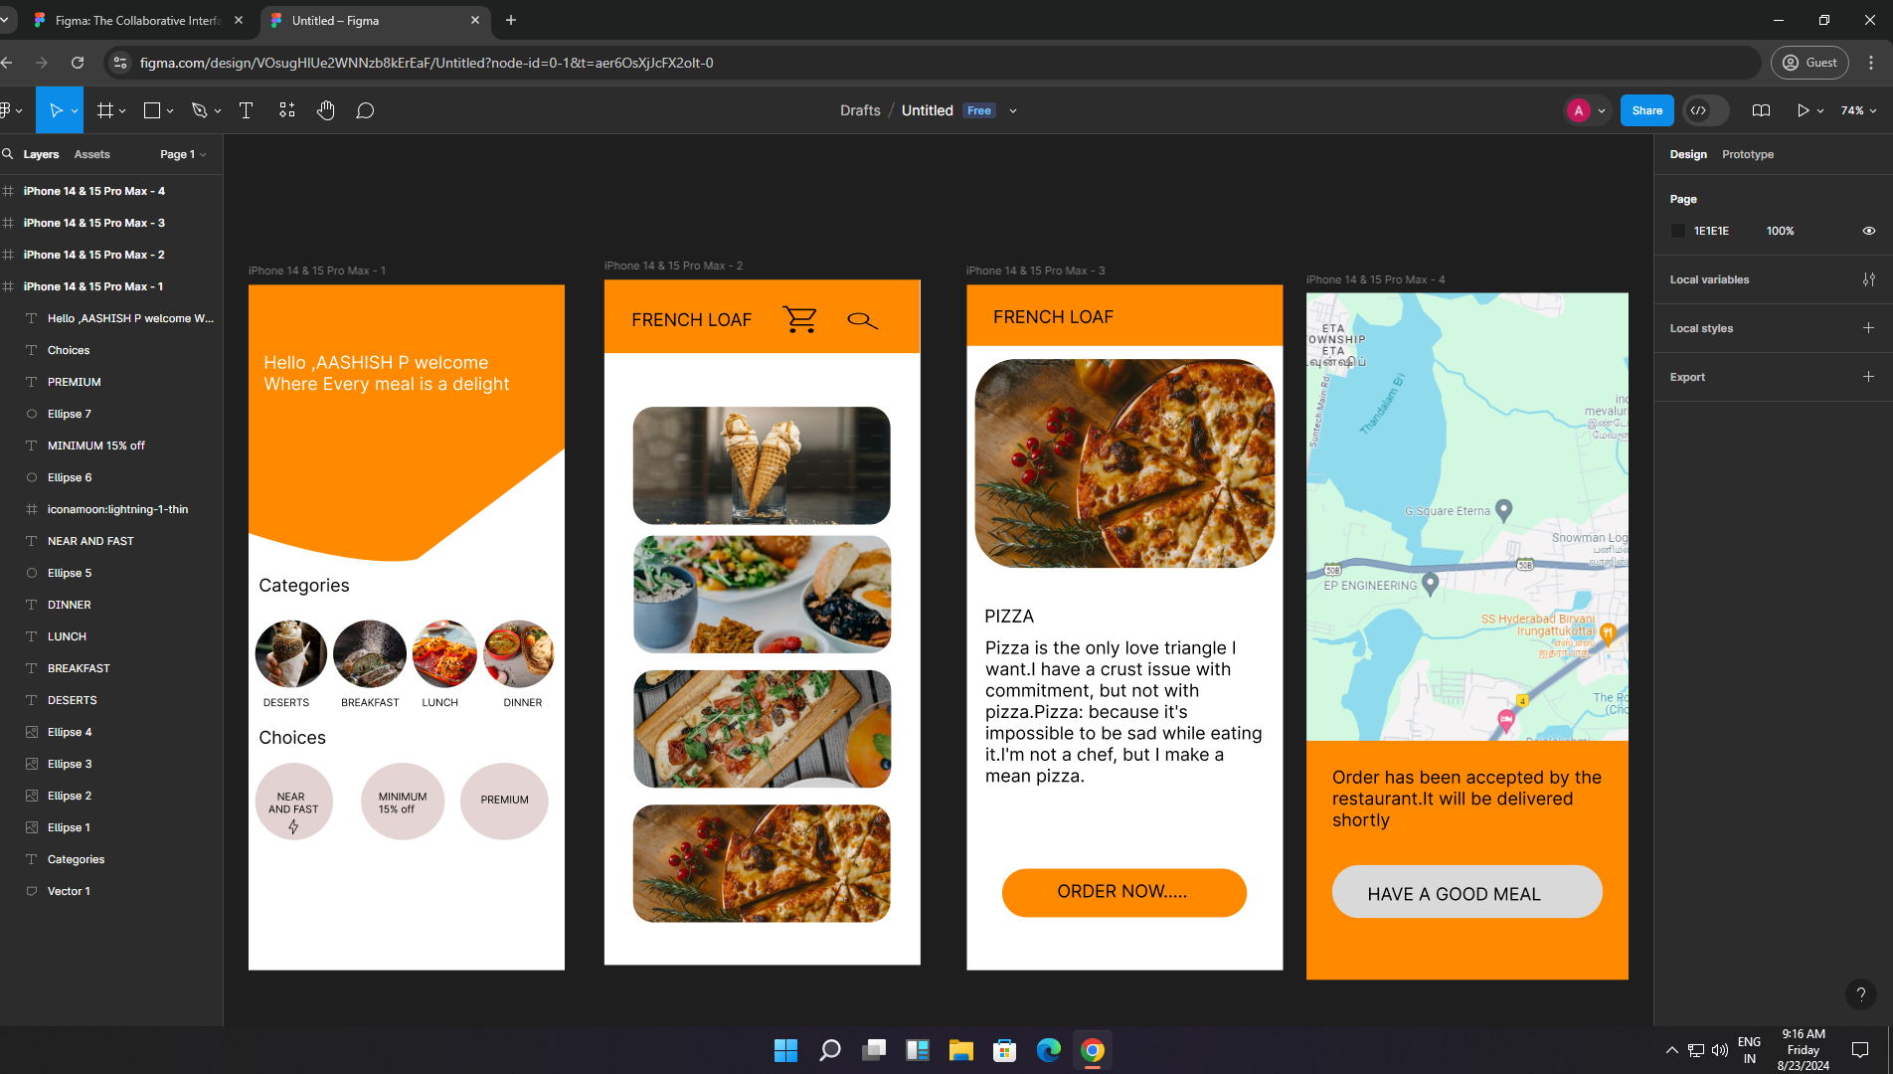

FINAL OUTPUT OF THE DESIGN